[Grab your reader’s attention with a great quote from the document or use this space to emphasize a key point. To place this text box anywhere on the page, just drag it.]

DESIGN DOCUMENT

Miss Manal Asghar
2512G2
Enrollment Number | Student Name
Student1714392 | AAZAF YOUSUF
Student1714399 | ABDUL MAJID
Student1714390 | ASIM AHMED

ACKNOWLEDGEMENT

We would like to express our deepest and most sincere gratitude to our respected instructor, Miss Manal Asghar, for her exceptional guidance, unwavering support, and professional mentorship throughout the lifecycle of this project. Her profound insights and technical expertise played a pivotal role in overcoming complex challenges and ensuring the successful completion of this work within the stipulated time frame. Without her constant encouragement, this level of excellence would not have been possible.
We are also immensely grateful to the e-Project team at Aptech Head Office for providing us with this prestigious opportunity to work on a specialized project centered around the world of Fine Arts and Painting. This project has served as a bridge between theoretical learning and practical application, allowing us to gain invaluable realworld exposure in the field of web development and digital design.
The e-Project learning journey has been a transformative experience for us. It has not only reinforced our core technical skills through handson, experiential learning but also provided a structured environment to refine our problem-solving abilities. Under the continuous supervision of our mentor, we were able to stay aligned with industry standards and best practices.
Furthermore, this endeavor has significantly boosted our professional confidence. It has equipped us with the ability to articulate complex concepts and demonstrate our project’s functionality effectively, which we believe will be a decisive asset in our future career pursuits and interview settings.

SYNOPSIS

The Elegance Salon Management System is a web-based application developed to simplify and organize the daily operations of a professional salon. The main purpose of this project is to provide a centralized system for managing appointments, clients, staff, inventory, scheduling, payments, and administrative activities.
The system allows salon staff to efficiently manage customer appointments, maintain client records, monitor salon products, organize staff schedules, and record payments. It helps reduce manual work and provides a more organized and efficient way of managing salon operations.
The project was developed using technologies including PHP, SQL, HTML, CSS, JavaScript, jQuery, and Bootstrap. During development, we gained practical experience in web designing, database management, form handling, validation, responsive layouts, and problem-solving.
This project also helped us understand how real-world business requirements can be converted into a functional web application. Through planning, development, testing, and implementation, we strengthened our technical skills and gained valuable practical experience.
In conclusion, the Elegance Salon Management System combines our web development knowledge with real-world salon management requirements to provide a structured, user-friendly, and efficient digital solution.

PROBLEM DEFINITION

Managing a salon manually can be time-consuming and may lead to problems such as appointment conflicts, difficulty maintaining client records, staff scheduling issues, inventory mismanagement, and inaccurate payment records. Using registers, notebooks, or separate systems makes it difficult to keep salon information organized and up to date.

Salon staff may also face difficulties in tracking customer appointments, monitoring available products, managing staff schedules, and preparing payment records. These issues can result in wasted time, data loss, and inefficient daily operations.

The Elegance Salon Management System is developed to provide a centralized digital solution for managing these activities. The system allows salon management to efficiently handle appointments, client information, staff, inventory, payments, and administrative tasks in an organized and user-friendly environment.

The main purpose of the system is to reduce manual work, improve data organization, minimize errors, and make the overall management of salon operations more efficient.

COSTUMER REQUIREMENTS SPECIFICATION

- User-Friendly Interface:
The website should have a clean, attractive, and easy-to-use interface that allows customers to navigate through the salon easily.
- Salon Services:
Customers should be able to view available services such as hair styling, haircuts, makeup, skincare, manicure, pedicure, and other salon treatments along with their prices and details.
- Online Appointment Booking:
Customers should be able to select a desired service, date, and time and book an appointment online.
- Customer Registration and Login:
The system should allow customers to create an account and securely log in to manage their personal information and appointments.
- Appointment Management:
Customers should be able to view their upcoming appointments and cancel or modify appointments when required.
- Salon Information:
The website should provide important information about the salon, including its location, contact details, working hours, and available facilities.
- Responsive Design:
The system should work properly on desktops, laptops, tablets, and mobile devices.
- Contact and Feedback:
Customers should be able to contact the salon and provide feedback or inquiries through an online contact form.
- Secure Data Handling:
Customer information and appointment data should be stored and handled securely.
- Fast and Reliable Performance:
The website should load quickly and provide smooth navigation without unnecessary complexity.

SCOPE OF THE WORK

The scope of the Galleria website project includes designing and developing a modern, user-friendly, and visually appealing website to showcase a wide variety of paintings. The main tasks covered in this project are:
- Creating a structured Home Page with proper sections, graphics, and a suitable logo.
- Designing clear and easy-to-use navigation links, including Home, About Us, Gallery, Contact Information, and Paintings.
- Ensuring uniformity in color schemes and maintaining an attractive, consistent look and feel throughout the website.
- Displaying a variety of paintings, categorized by type (Abstract,
Landscape, Flower, Nature, Figurative, Religious), surface (Acrylic, Canvas, Paper, OHP Sheet, Fabric), and color type (Acrylic, Ball Point Pen, Charcoal, Oil, Watercolor, Poster, Enamel, Ink).
- Providing detailed information for each painting, with an option to save the details as a Word document.
- Implementing smooth site navigation, a site map, gallery section, and FAQs for a better user experience.
Overall, the project aims to enhance Galleria’s online presence, improve user engagement, and make it easier for customers to explore and appreciate the wide range of paintings offered by the company.

SITEMAP GUIDE (GALLERIA)

Page Name | File Name | Category / Parent
Main Root / Home | index.html | Website Entrance
Visual Archive | gallery.html | Main Pages
Shop Paintings | paintings.html | Product Hub
About Us | about.html | Company Info
Art Blog | blog.html | Content
Contact Us | contact.html | Communication
Login System | login.html | Authentication
Sign Up | signup.html | Authentication
User Profile | user-profile.html | User Dashboard
Shopping Cart | cart.html | E-commerce Flow
Wishlist | wishlist.html | E-commerce Flow
Checkout | checkout.html | E-commerce Flow
Order Success | order-success.html | Confirmation
FAQs | faqs.html | Support
Events | events.html | Support
Terms & Conditions | Terms.html | Legal
Privacy Policy | privacy.html | Legal
Shipping Policy | shipping-policy.html | Legal
Sitemap | sitemap.html | Website Navigator

Galleria VIP - UI Wireframes

Home Page (index.html)
Main landing page focused on brand identity and top categories.
 | LOGO | Home | Gallery | Paintings | About | Login [Cart Icon]
  HERO IMAGE: The Art of Living"[Button: Explore Now]
  Journey (Counter up)
 | Category: Abstract |  | Category: Landscape |  | Category: Religious
 | Explore More Card buttons (Upcoming Events) (blog)
 | Reviews card
 | Footer: Links | Social Media | Copyright © 2026

About Us (about.html)

Galleria VIP | Our Story Section
 | Navigation Bar (Logo | Home | Gallery | About...)
  About Header Section "Our Journey & Vision"
 |  | Our Story / Mission  Detailed text about the gallery's origin, passion for  art, and commitment to artists.
  Image Placeholder (Gallery Interior)
 |  |  | Core values card  Global reach  passion
  authenticity
 |  | Footer: Links | Social Media | Copyright © 2026

Contact (contact.html)
Galleria VIP | Customer Support & Location
Navigation Bar (Logo | Home | Gallery | Contact...)
Contact Information    📍 Visit Gallery    📞 +91 123 456 7890    ✉️support@galleriavip.com |  |  | Send us a Message
  [ Name Field ]
  [ Email Field ]
  [ Subject Field ]
  [ Message Text-area ]
Google (Location
Map Embed Placeholder)

  SUBMIT
Footer: Links | Social Media | Copyright

Paintings Listing (paintings.html)
Galleria VIP | Product Listing & Art Details
Navigation Bar (Logo | Home | Gallery | Paintings | About...)
[ Search Icon] Search for Art... | Filters: All / Abstract / Landscape / Religious / Nature
Masterpiece 1  $250 |  |  |  | Masterpiece 2  $400 |  |  |  | Masterpiece 3  $150
  Painting Image
  Painting Image
  Painting Image
 | VIEW / ADD TO CART |  |  |  | VIEW / ADD TO CART |  |  |  | VIEW / ADD TO CART
Art Detail Popup (Modal)
Large Image Preview | Title:  Artist:  Price: $250
Large Image Preview | DOWNLOAD DOC
Abstract
Emotion
Footer: Privacy | Terms | Shipping | Social Icons

Gallery (gallery.html)
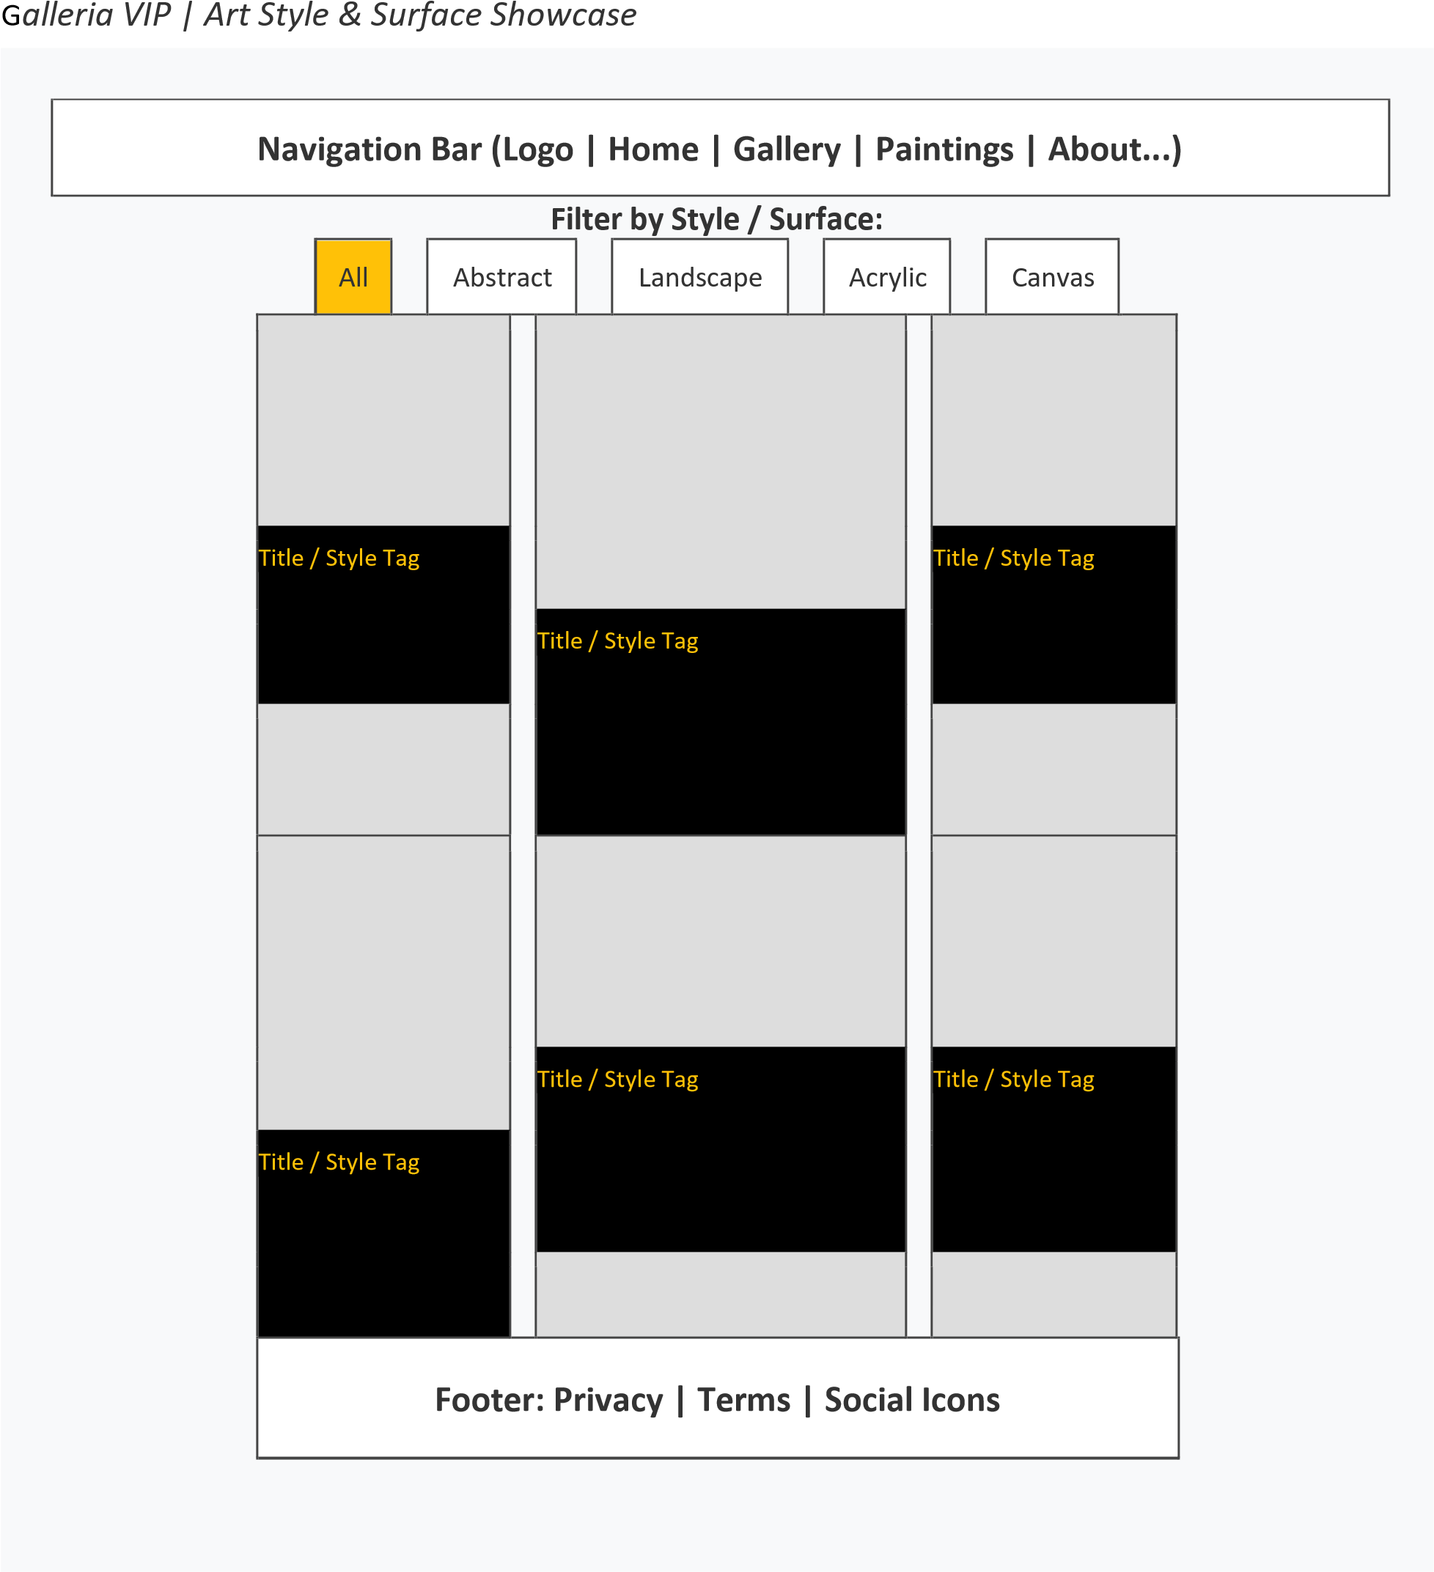

TASK SHEET 1

No | Task | Actual Start Date | Actual Days | Team-mate Name | Status
1 | Build Home Page | 27/03/2026 | 2 | AAZAF YOUSUF | Complete
2 | Build Product & Paintings Page | 30/03/2026 | 2 | AAZAF YOUSUF | Complete
3 | Build Gallery, About & Contact | 01/04/2026 | 5 | AAZAF YOUSUF | Complete
4 | Build Price/Checkout Page | 02/04/2026 | 3 | ASIM AHMED | Complete
5 | Product Line-up | 01/04/2026 | 1 | ABDUL MAJID | Complete
6 | Register/Login | 04/04/2026 | 2 | SABIRA | Complete
7 | Browser Support Code | 10/04/2026 | 1 | TEAM EFFORT | Complete

TASK SHEET 2

No | Task | Actual Start Date | Actual Days | Team-mate Name | Status
1 | Responsive Check (Home) | 10/04/2026 | 2 | SABIRA | Complete
2 | Color/Format Check (Paintings) | 11/04/2026 | 2 | ABDUL MAJID | Complete
3 | Tech/Support Check | 10/04/2026 | 2 | AAZAF YOUSUF | Complete
4 | Developer Guide | 15/04/2026 | 2 | SABIRA | Complete
5 | User Manuals | 15/04/2026 | 2 | ASIM AHMED | Complete
6 | Overall Project Inspection | 16/04/2026 | 2 | ALL MEMBERS | Complete

